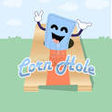

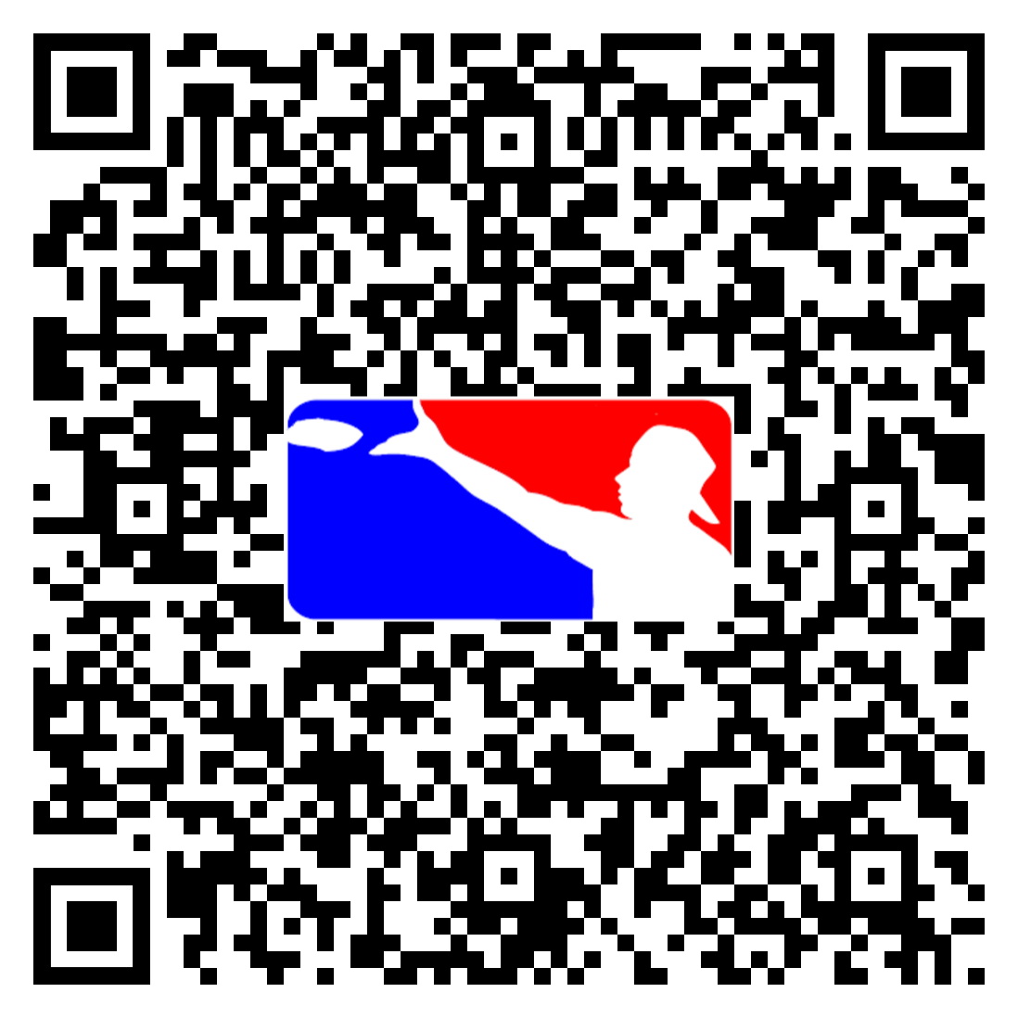

**2ND ANNUAL NC CASE CORNHOLE TOURNAMENT**

**SPONSORED BY PCG**

**SPONSORED BY PCG!**

**TUESDAY, OCTOBER 3**

**5:00 – 7:00**

**PLAY AS A TEAM, PLAY AS AN INDIVIDUAL USE THE QR CODE TO SIGN UP**

**FOOD AND BEVERAGES PROVIDED BY PCG**

**YOU NEVER KNOW WHO IS GOING TO SHOW UP!!**

**COME OUT AND PLAY OR WATCH! NETWORK. RELAX. EAT. DRINK. JOIN US AT THE PALMS OF LUMINA FOR A FUN EVENING!!**