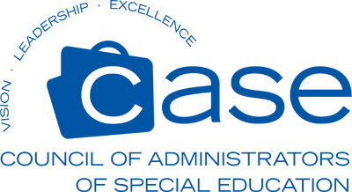

Annual Fall Conference Registration
October 1 – October 4, 2023
Holiday Inn Resort
1706 Lumina Ave
Wrightsville Beach, NC 28480
(910) 256-2231

Name:___________________________________Position:_______________________________________

School District: _________________________________________________________________________

Address:_______________________________________________________________________________

Email: ____________________________________Phone: ______________________________________

Registration Cost
Includes Materials, Reception, Breakfasts and Lunches

_____ $300.00 CEC/CASE Members Membership # Required :___________Exp date:_________
(Price increases to $350.00 after September 15, 2032)
_____ $350.00 Non-Members (and members after 9/15/23)
_____ $200.00 Retired EC Directors
_____ $125.00 Guest/Spouse (One guest per participant: Meals only)

We encourage you to be our guest at the kick-off reception on Sunday evening, October 1. This is a great time to meet and greet!
I plan to attend the Sunday evening reception ______Yes ________No

REGISTRATION/PAYMENT INFORMATION
Please be advised that no refunds will be issued after 9/15/23
Registration forms may be emailed to towens@highpoint.edu
Checks payable to: NCCASE
Mailing Address: High Point University
One University Parkway Attn: Teresa Owens
Stout School of Education Drawer 45
High Point, NC 27268

Please contact Teresa Owens with conference/payment questions.
towens@highpoint.edu Phone: (336) 841-9411

