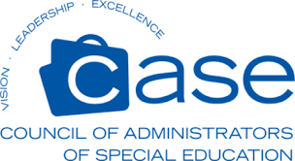
Vendors!
Save the Date!
NC CASE ANNUAL FALL CONFERENCE
October 1-4, 2023

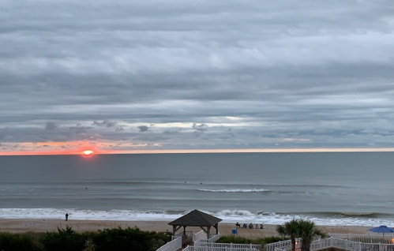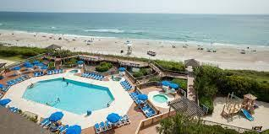
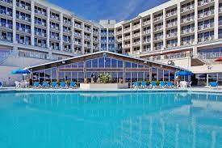
HOLIDAY INN OCEANFRONT RESORT
WRIGHTSVILLE BEACH, NC
What are the Benefits of Joining Us?
- Four days of Professional Networking Opportunities with direct access to over 100 NC Special Education Administrators
- Three participation levels for vendors. See link to registration form below.
- Opportunities to sponsor events during the conference. See link below.
- Vendors included in all Conference Activities (breakfasts, lunches & receptions)
- NCCASE pays for hotel set-up fees for vendor spaces
- NCCASE provides all vendors with our Attendee Contact List
Email Mike Marcela marcelam@wataugaschools.org Sandy Albert salbert@mgsd.k12.nc.us or Teresa Owens at towens@highpoint.edu with conference questions!
Vendor Registration Form
Event Sponsorship NCCASE 2023

